Growing consumer interest in a healthy diet and wellness benefits has led to a thriving food & beverage industry in the recent past and this trend is expected to continue over the forecast period. This, in turn, is projected to propel the demand for superfoods in the coming years.

**Increasing healthcare costs, growing geriatric population, food innovations, changing lifestyle, and medical discoveries have benefitted the demand for superfoods and consequently the overall market growth.Growing concerns in the U.S. regarding obesity and overall health are also contributing to the market growth.** ← good idea of how to market

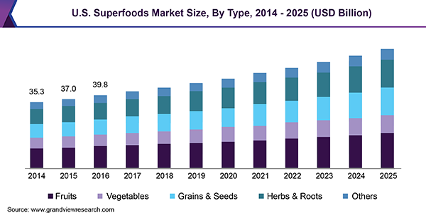

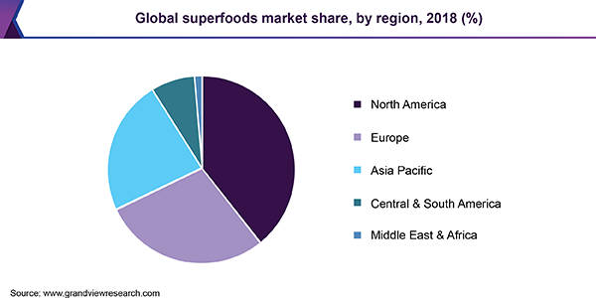

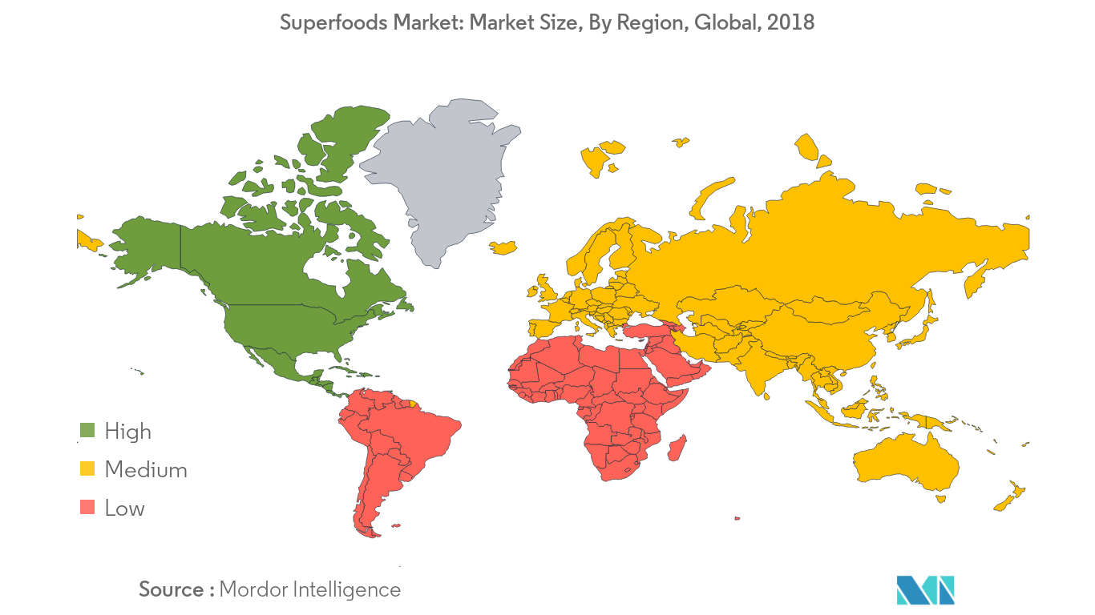

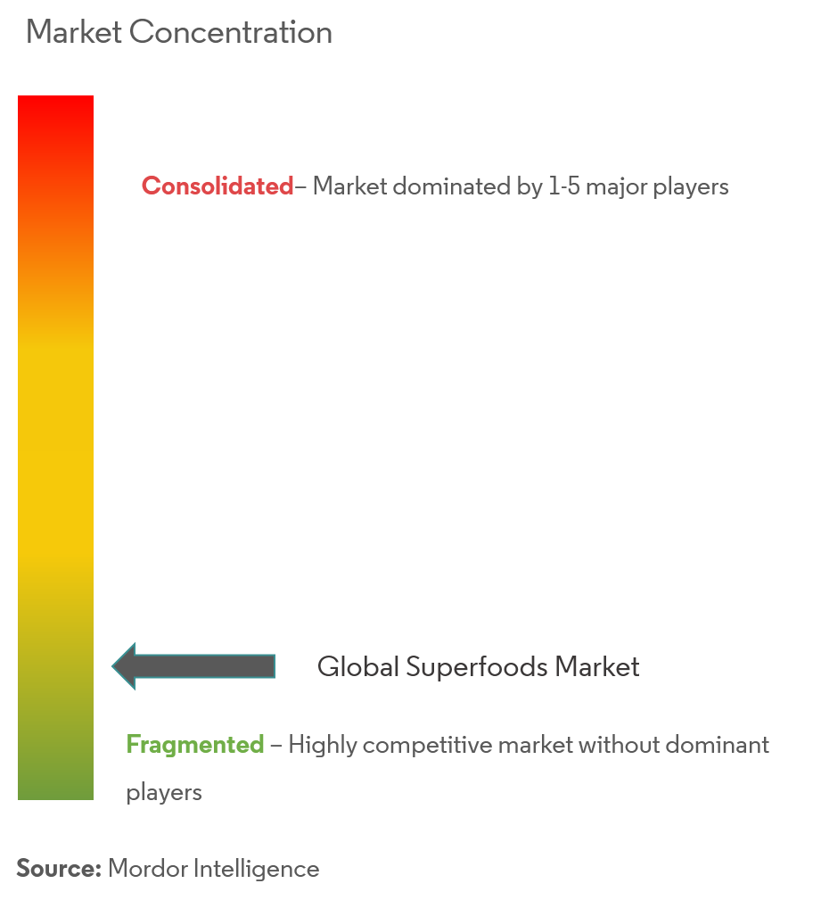

A lot of opportunity to become a major dominant player since monopolies haven’t been reached

